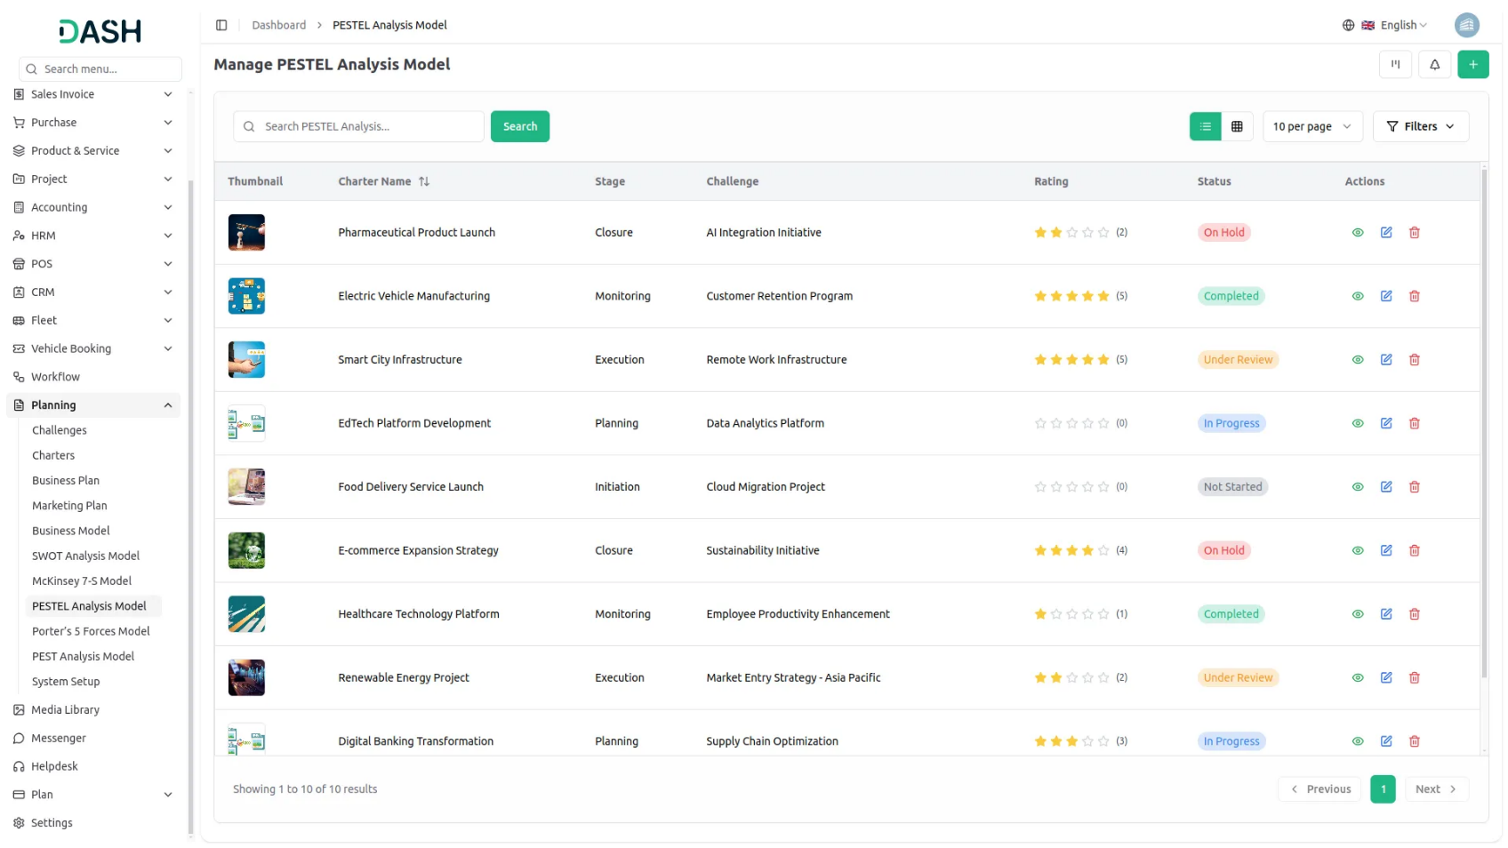

The Porter's Five Forces Add-On empowers businesses to strategically analyze their competitive environment using a structured framework. Users can create detailed models by capturing key aspects such as challenges, threats of substitution, bargaining powers, and organizational effects. With flexible views like grid, kanban, and tree organized by challenges, it enhances visualization and decision-making. Users can also attach relevant files, add reviews, and print the model for sharing or presentation purposes.
Dependency Notice: This Add-On depends on the Planning Add-On, so you must purchase and activate it first to access the Porter's Five Forces features.

STRONG BRAND
Strategic Model Insights
Get a comprehensive view of your Porter's Five Forces model in one place. This page displays key details like name, status, stage, rating, and all strategic inputs including supplier and buyer power, threats, and organizational effects. Attachments, notes, and comments enhance collaboration, while the rating can be updated directly for real-time insights.

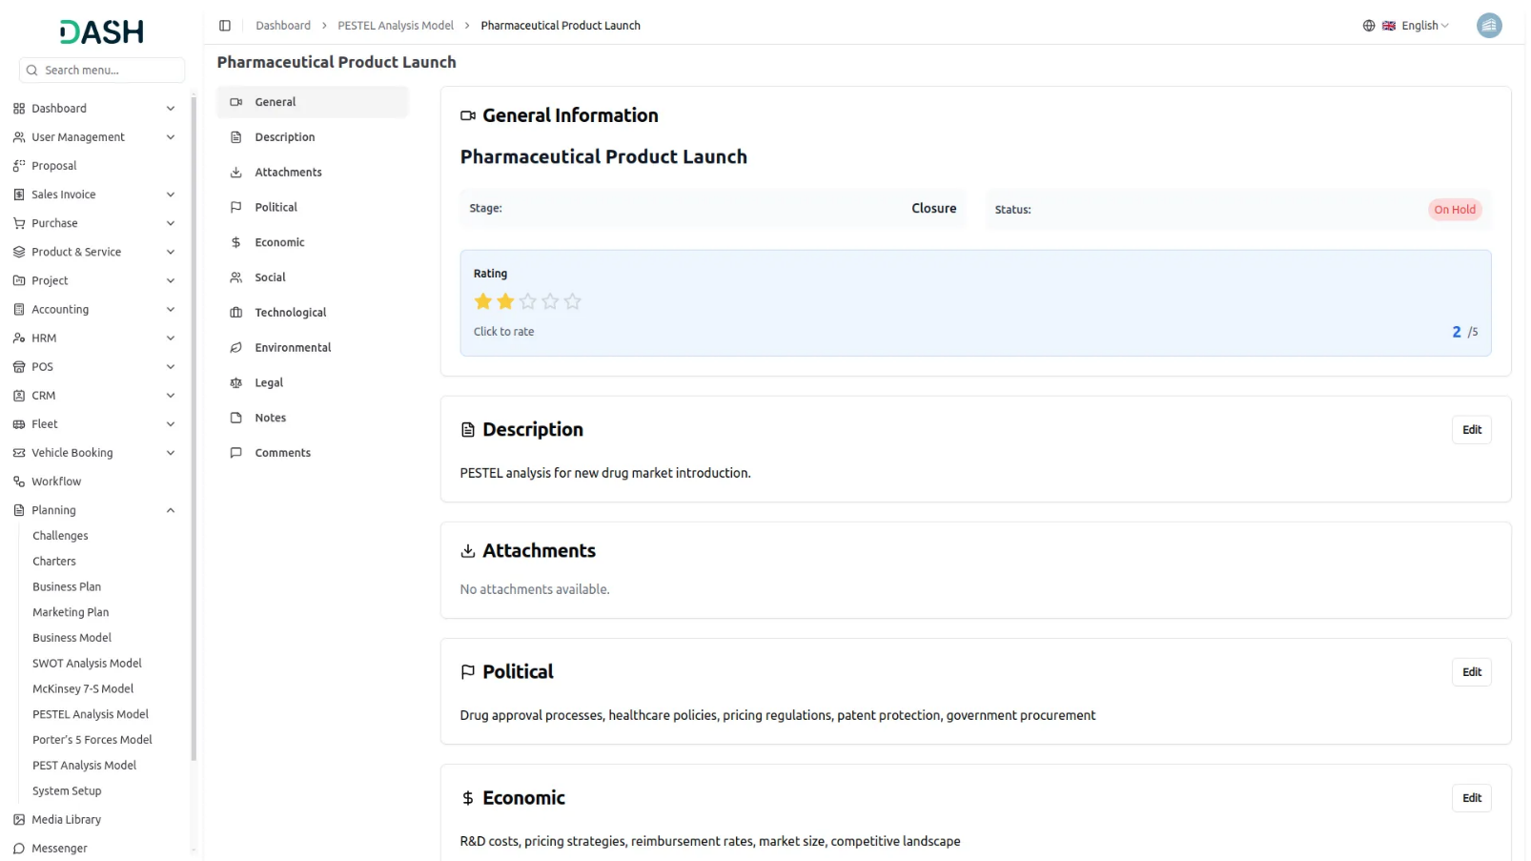
Competitive Intelligence Grid
View all your Porter's Five Forces models in a structured grid layout for quick analysis and management. This section displays key details such as total comments, attachments, challenge end time with timer, and assigned users for each model. Users can easily print, edit, or delete models, making it a centralized hub for strategic planning and execution.
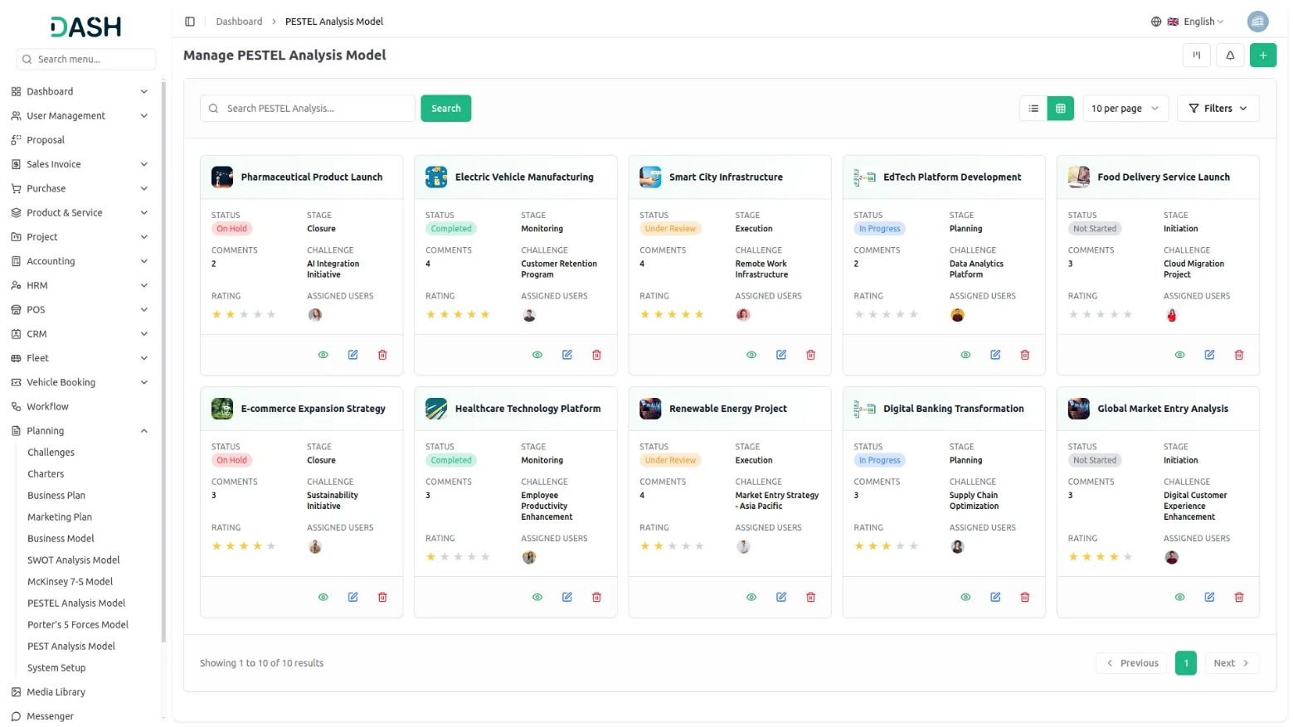
Kanban Strategy View
Visualize your Porter's Five Forces models in a dynamic Kanban board, organized by stages. Effortlessly drag and drop models between stages, track their progress, and manage strategic actions in real time. View total models per stage and take quick actions like edit, print, or update with ease.
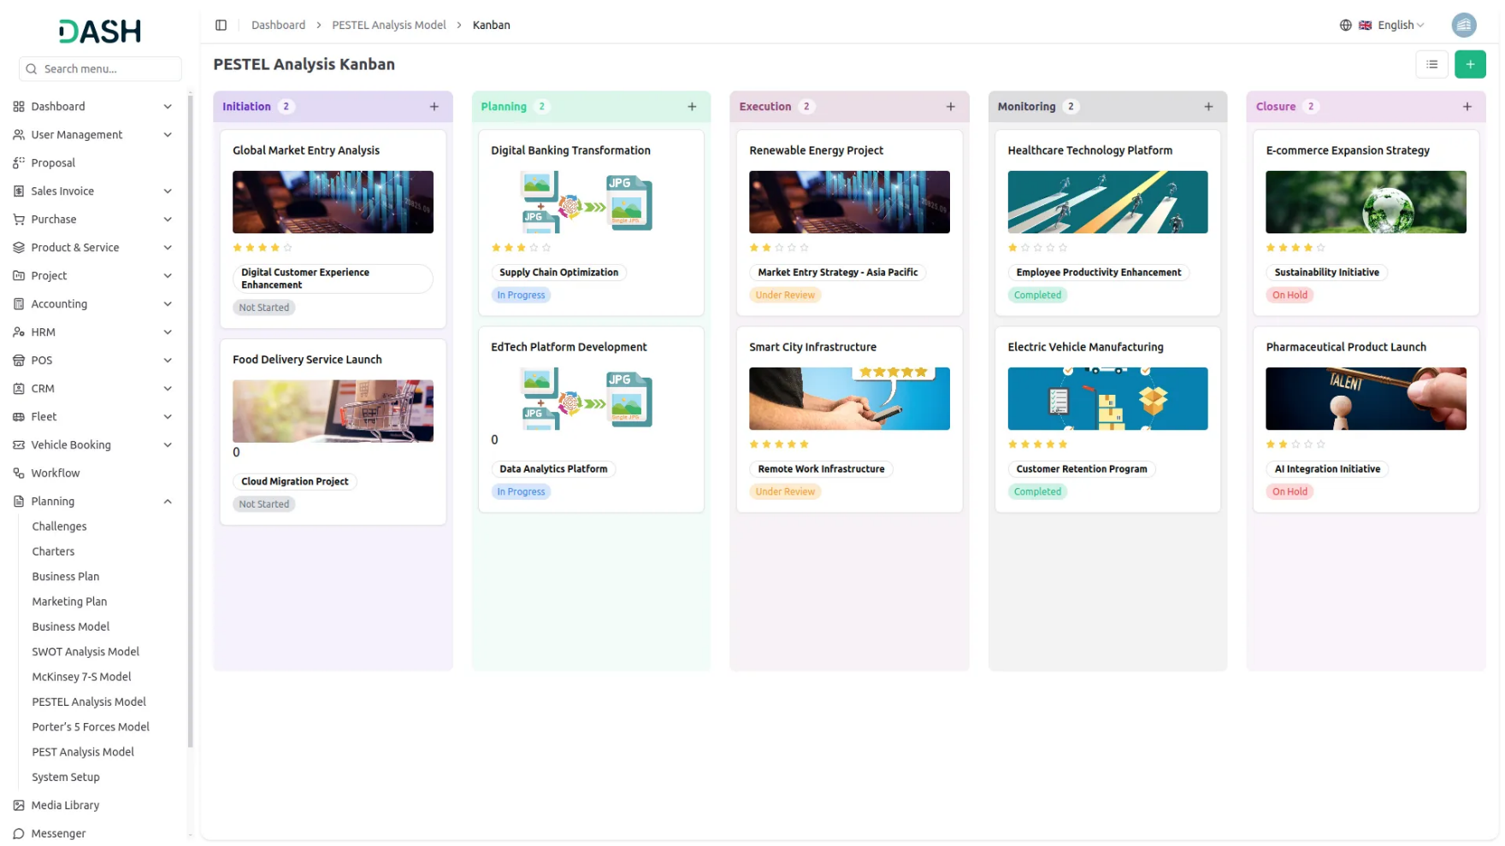

Challenge-Based Tree View
Explore your Porter's Five Forces models in a clear, tree-structured view filtered by business challenges. Select a challenge from the dropdown to visualize related models in an organized, hierarchical layout. This helps you uncover deeper insights and align strategic responses effectively.

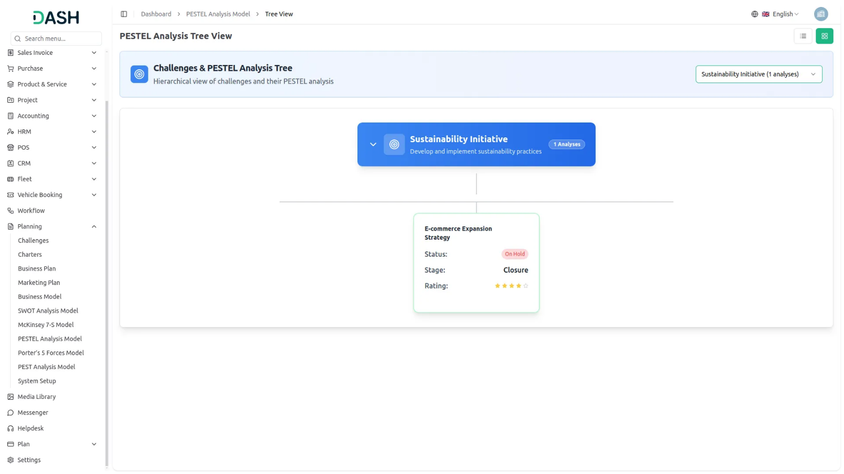

Introduction
Porter’s Five Forces Model is a strategic analysis software designed to help businesses evaluate competitive forces within their industry. This system allows organizations to create comprehensive analyses using Porter’s framework, which examines five key competitive forces: threat of new entrants, bargaining power of suppliers, bargaining power of buyers, threat of substitute products, and competitive rivalry. The software enables teams to collaborate on strategic assessments, track progress through different stages, and generate detailed reports for informed decision-making.
Note: This Add-On is dependent on the Planning Add-On, so you need to purchase it first.
How To Use the Porter’s Five Forces Model Add-On?
Manage Porter’s Five Forces Model
- The default List View displays all Porter’s Five Forces Models in a comprehensive table format with multiple management options. At the top of the page, you’ll find buttons for Create Porter’s Five Forces Model to add new analyses, plus three alternative viewing options for different management preferences.
- The main table presents detailed information with columns for Thumbnail Image providing visual identification, Name of the analysis model, Status fetched from System Setup showing current progress, Stage fetched from System Setup indicating analysis phase, Challenge fetched dynamically from Challenge Table showing associated business objectives, Rating for performance tracking, and Action column with management options.
- In the Action column, you have powerful options available: View to access complete analysis details and all strategic information, Edit to modify any aspect of the model including strategic assessments and team assignments, and Delete to remove analyses that are no longer relevant to your business strategy.

Creating Porter’s Five Forces Model
- To create a new Porter’s Five Forces Model, click the “Create” button at the top of the page. Start by entering the Name for your strategic analysis model, which should clearly identify the scope or focus of your competitive analysis.
- Select the Challenge from the dropdown menu, which fetches data from the Planning Challenge. Important note: if the current date is greater than the Challenge End Date, you will not be able to create a Porter’s Five Forces Model, ensuring all analyses remain aligned with active or future business challenges.
- Upload a Thumbnail Image to provide visual identification for your analysis model, and Upload Video content if you have supporting presentations or explanatory materials. Choose the appropriate Status from the dropdown menu, which fetches options from System Setup, and select the relevant Stage also fetched from System Setup to indicate the current phase of your analysis.
- Assign the Users involved in this strategic analysis by selecting from the Users Table, and choose the appropriate Role from the Roles Table dropdown to define team member responsibilities. Add a comprehensive Description that outlines the purpose and scope of your competitive analysis.
- Continue with the strategic analysis components by entering detailed information for Threat of Substitution, explaining how substitute products or services might impact your industry position. Add relevant Notes for additional observations or methodology details, and attach supporting files through the Attachments field for research data, market reports, or reference materials.
- Document the Organizational Effects that this analysis may have on your business strategy and operations. Provide a clear Goal Description outlining what you aim to achieve through this competitive analysis.
- Complete the remaining two critical forces by entering comprehensive details for Bargaining Power of Supplier, analyzing how supplier relationships affect your competitive position, and Bargaining Power of Buyers/Customers, evaluating customer influence on pricing and terms. Once all fields are completed, click “Create” to create your Porter’s Five Forces Model.

Viewing Porter’s Five Forces Model
- When you click the “View” button from the Action column, you access the comprehensive detailed model view that displays all information about a specific Porter’s Five Forces analysis. This view is organized into several sections for easy navigation and thorough review of your strategic assessment.
- The General Details section shows the basic model information including name, status, stage, associated challenge, assigned users, and roles. In the Description section, you can view the current analysis description and add additional details using the “Edit” button.
- The Attachments section shows all files associated with the model including market research, competitor data, and supporting documentation. You can add new attachments using the “Edit” button to include additional research materials. The Organizational Effects section presents the documented impact of this competitive analysis on your organization’s strategy and operations. Use the “Edit” button to include additional organizational effects.
- The Goal Description section displays the analysis objectives and allows you to add more detailed goal descriptions using the “Edit” button.
- The Bargaining Power of Supplier section shows your assessment of supplier influence and market dynamics. You can add additional supplier analysis using the “Edit” button as you gather more information about supplier relationships and market conditions.
- The Bargaining Power of Buyers/Customers section presents your evaluation of customer influence on pricing, terms, and market position. Use the “Edit” button to include additional buyer analysis as customer behavior patterns and market preferences evolve.
- The Threat of Substitution section displays your assessment of substitute products or services and provides an “Edit” button to include additional threat analysis as market conditions change or new substitutes emerge in your industry.
- The Notes section displays all analysis notes and provides an “Edit” button for including additional observations, methodology notes, or important strategic insights that don’t fit in other specific categories.
- Finally, the Comments section enables team collaboration through written communication about the competitive analysis. You can write comments about findings, ask questions about specific competitive forces, or provide updates on market changes. This section also includes the ability to upload attachments directly with your comments.

Kanban View
- To switch to Kanban View, click the “Kanban View” button at the top of the page. This view organizes Porter’s Five Forces Models in columns based on their current stage or status, with each model appearing as a moveable card containing essential information.
- The Kanban View includes powerful drag and drop functionality that allows you to easily move analysis models between different stages by simply dragging a model card from one column to another.
- In the Kanban view, each card displays the thumbnail image, status, rating, associated challenge, and the Porter’s Five Forces model name. By clicking on the three-dot menu on a specific card, a dropdown appears with options to view, edit, or delete the model.

Tree View
- To switch to Tree View, click the “Tree View” button at the top of the page. This view presents a hierarchical structure that displays challenges and their associated Porter’s Five Forces Models in an expandable tree format, showing the parent-child relationships clearly.
- The Tree View includes expand/collapse functionality, indicated by the arrow icon next to each challenge name. Clicking the arrow allows you to expand the challenge to reveal its associated models or collapse it to show only the challenge title, making navigation more organized and focused.
- In the Tree view, each challenge appears as a blue header bar with the number of plans indicated. When expanded, it displays the associated models beneath it in card format, showing key details including the model name, status, stage, and rating displayed as stars.

